How to set up a PHP server on MAX OS

1. download phpStorm from <https://www.jetbrains.com/community/education/>
2. use your UTS student email to register a free student account
3. install PHP in terminal:   
   brew install php  
   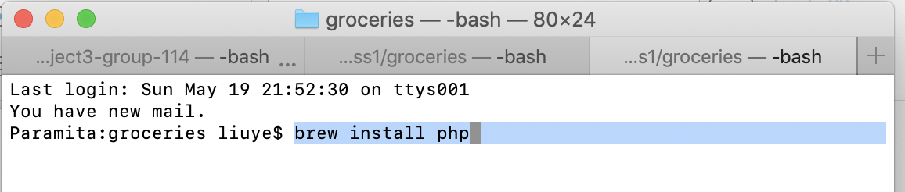
4. open phpStorm, register it
5. create new Project, name it “HelloWorld” or anything.
6. Press Command + , to open preference tab, go to **language & Frameworks** > PHP Configure PHP  
   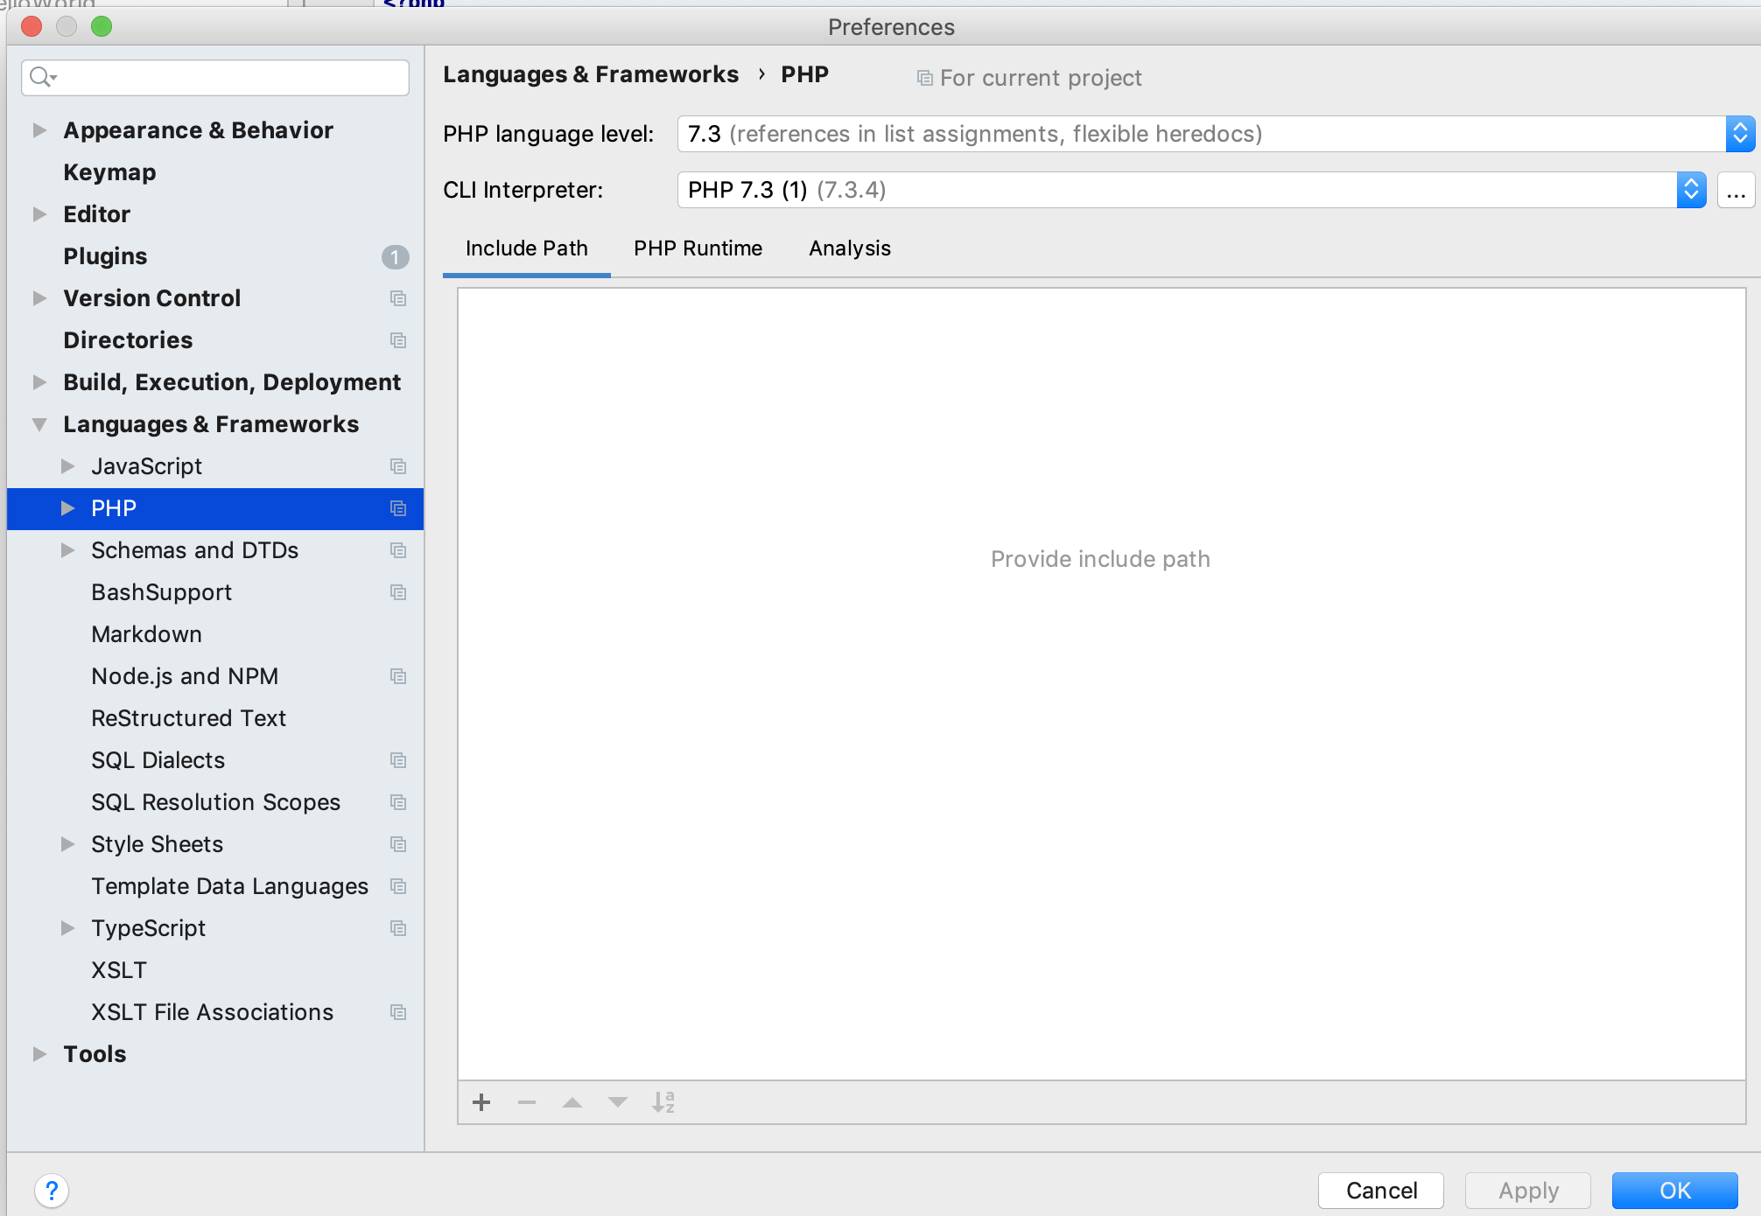  
   specify language level  
   click ‘…’ to configer CLI Interpreter:  
   click +, then (the PHP executable must be a folder that has php excutable files, and also a php.ini, this php.ini file can be downloaded from the internet)  
   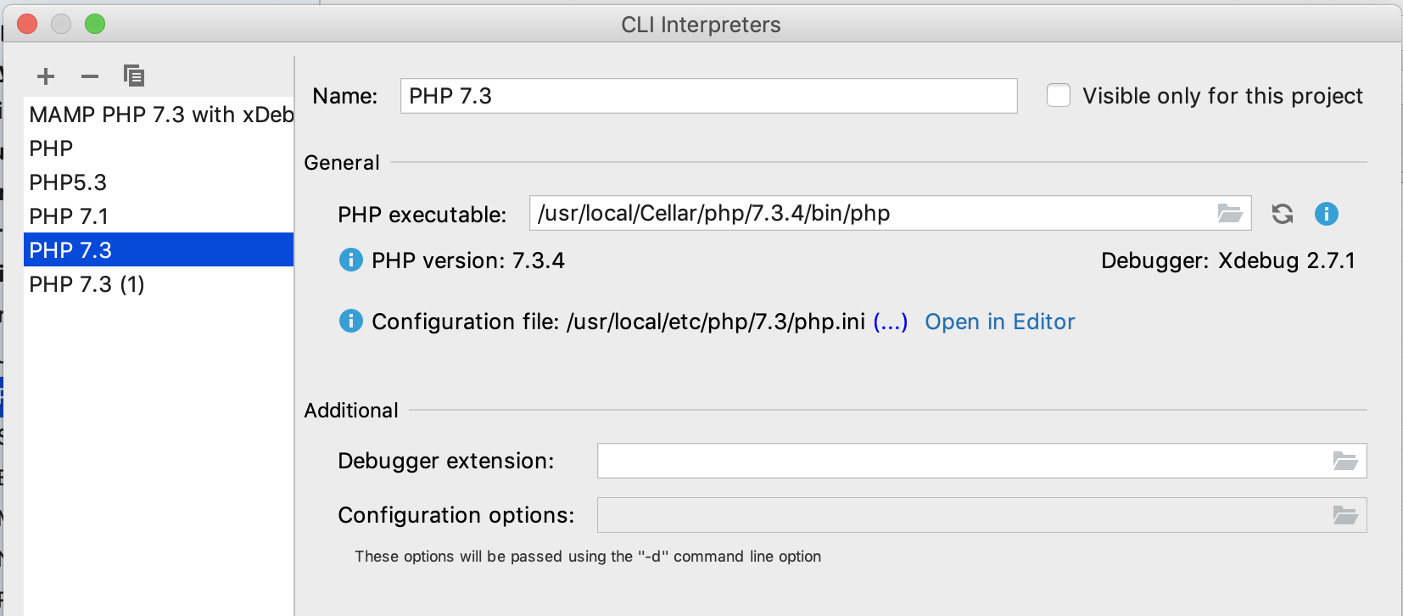
7. Configure the server: click “edit configurations” to open server configurations  
   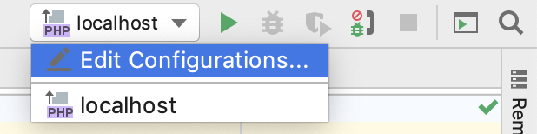
8. Add a new PHP Built-in Web Server   
   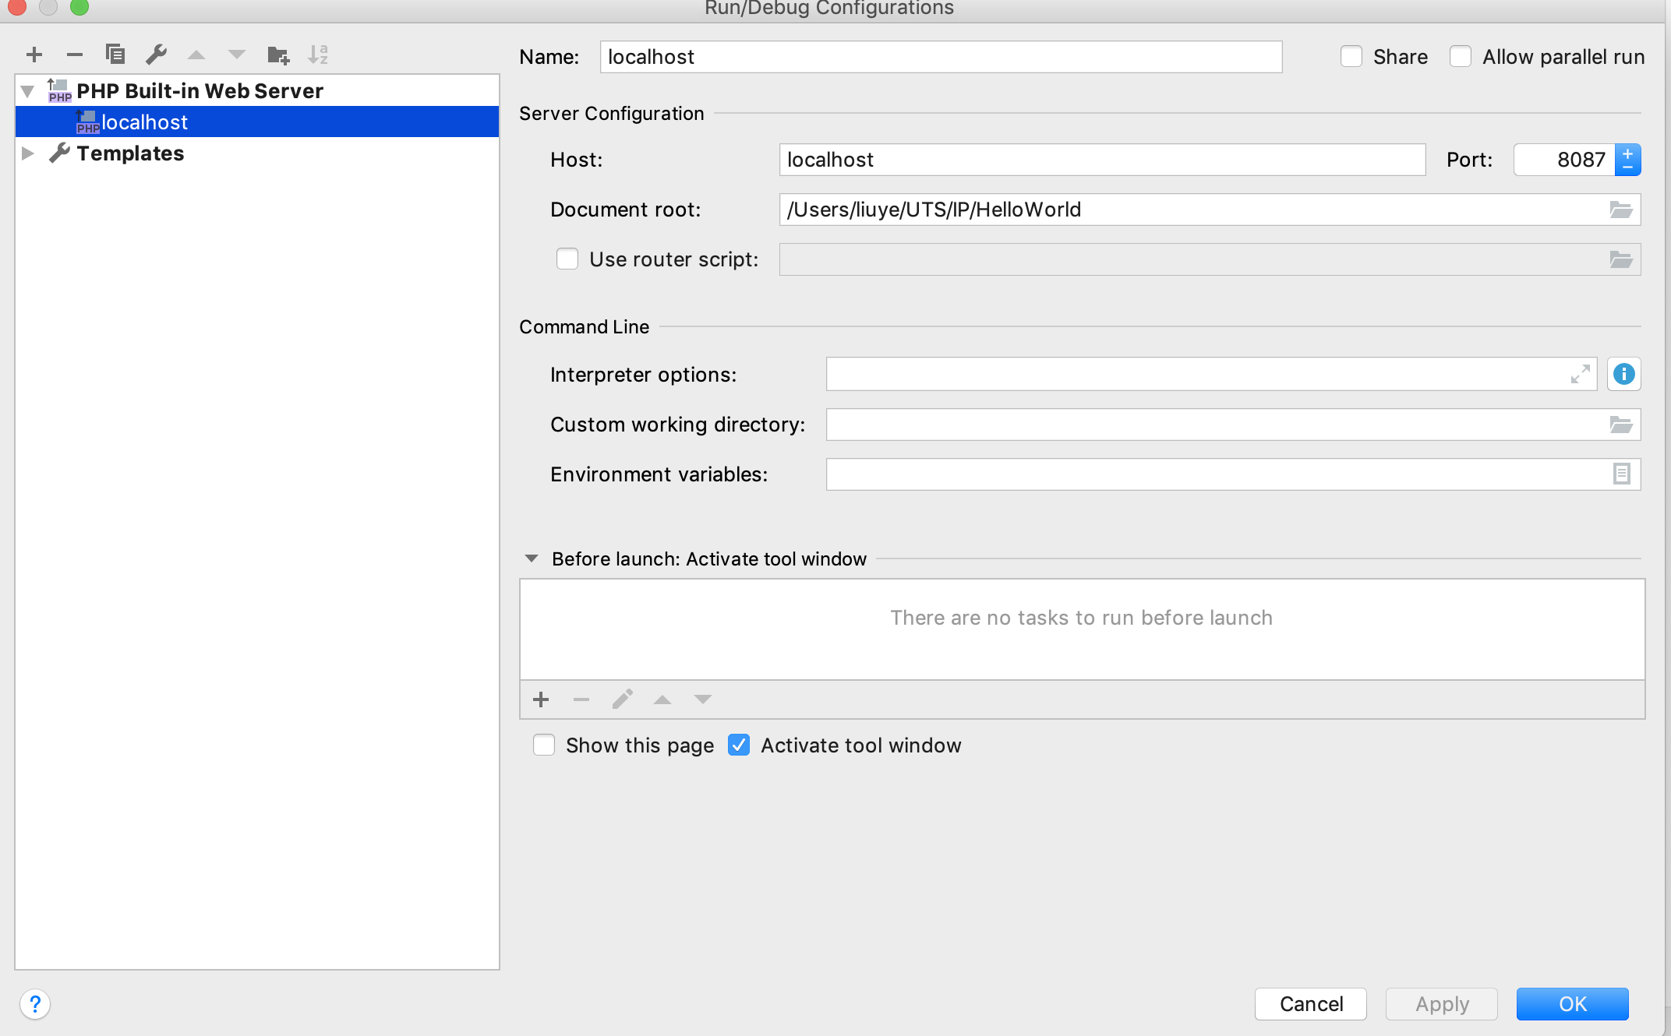
9. Create a sample index.php file under the project
10. 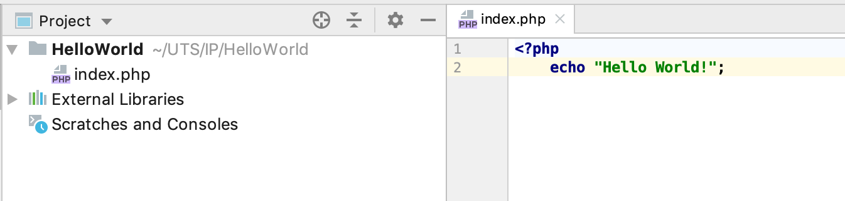
11. Click  to run
12. Go to browser, type localhost:8087
13. 